Traffic lights T-AT

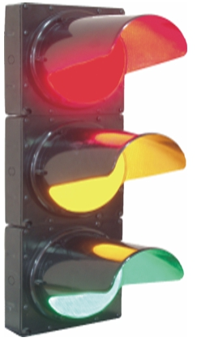
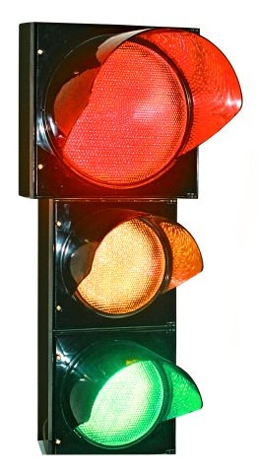

LED transport traffic lights (T-AT) are intended for traffic control of vehicles during passage through the signal controlled intersections and other difficult sections of road system.

The LED modules (MS) of red, yellow and green colors are light sources in T-AT. MS are built in the traffic light housing. The housing is made of black or gray impact-protected polycarbonate (the type of the housing is defined at the order).

The nomenclature of MS includes modules of red, yellow and green emission colors for the main and additional sections of traffic lights of standard sizes 200 and 300 mm.

MS compares favorably from the modules with glow lamps with essential impossibility of a false color illumination of the disconnected sections at their lighting from the outside, with higher brightness, by 10 times lower power consumption and essential higher reliability.

Light-emitting diodes are included in MS in such a way that failure up to 20% of LEDs doesn't result decrease in light intensity of the module due to compensation of a light flux by other light-emitting diodes.

The T-AT lighting parameters meet the requirements of DSTU 4092-2002 and TU U 31.6-14228451-007-2003. The light flux formed by MS has 30% reservoir on luminous intensity for compliance continuance to requirements of DSTU when aging light-emitting diodes and connected with it deterioration of the radiating capacity.

Modifying of the existing road controllers of types DKM and UK isn't required at application of T-AT.
The LED transport traffic light T-AT ensure the twenty-four-hour automatic work in the open air in the range of temperatures from – 40°C (during the continuous work from – 50°C) to + 60°C.

