Traffic lights P T1.1-AT

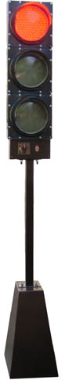

Portable traffic light P T1.1-AT is intended for the successive passing of vehicles through the road under repair at high intensity of traffic or at insufficient visibility of roadway maintenance work.

It is applied together with the warning road sign 1.24 “Traffic Signal Ahead”.

It consists of the LED traffic light T1.1 according to the DSTU 4092-2002 with a nominal power supply voltage of light signals sources 12 V of the direct current installed on a rack which basis is a cabinet for the automobile 12-volt battery, and the manual control panel located directly under the traffic light.

The on-start switch of the traffic light signals in sequences the red - yellow - green - yellow - red - yellow, etc., and the switch of the on-off power and the traffic light transfer to the mode of the yellow flashing signal are located on the panel.

The battery isn't included in the package of delivery.
NOTE: By request the traffic light P T1.1-AT can be completed with the portable manual control panel or the controller providing on a radio channel mutually agreed switching of two traffic lights P T1.1-AT through a rigid two-phase cycle.

